15/05/2018

Autonomous thanks to solar power
A solution for water supply in remote areas
The demand for water continues to grow. Especially in arid and remote regions the reliable supply of water represents a challenge. Wilo, the Dortmund technology company, sees great potential in the solar-powered Wilo-Actun OPTI-MS. The submersible pump is independent of the power grid and provides optimal water output, which can be adjusted to suit the user’s own demands.
Water demand is growing worldwide. Here, climate change is only a problem for freshwater supplies. Continual population growth, advancing urbanisation, rising needs in agriculture and the increasing pollution of water are far more problematic. In many countries droughts and water shortages cause suffering to those affected and pose an existential threat for agriculture as an industry. “Ground water is an important source for the water supply. It can be pumped from wells and shafts using submersible pumps”, says Roman Zielinski, product manager at Wilo. “However, in remote areas a stable power supply is often problematic as, normally, there is either no mains power grid or the network is very instable. We have adapted an alternative method, using which we can reliably generate energy locally and use it to supply water.” A pump which is supplied with electricity from solar power. Solar power is free and readily available without the need for infrastructure such as power cables or roads to transport fuel.
Water supply in remote regions
The Wilo-Actun OPTI-MS is designed to be used in conjunction with photovoltaic systems to form an autonomous water supply system.
Besides pumping drinking water to supply small settlements, it is also suitable for agricultural irrigation and livestock farming. The integrated frequency converter means it is possible to use both solar power as well as being connected to an alternating current mains supply. The alternating current mains supply can be viewed as a “backup” when no solar power is available but where, for example, the water must continue to be pumped for a limited time in case of a special need. The Actun OPTI-MS guarantees optimal water output thanks to its high motor and hydraulic efficiencies and a dynamic Maximum Power Point Tracking algorithm (MPPT): “How much power the solar panel can provide depends on the sun – the respective performance potential depends on the location, time and weather”, explains Zielinski. “The integrated microprocessor calculates the optimal ratio between electric current and voltage using the MPPT algorithm, in order to demand the greatest amount of power. The result is a higher speed and therefore a greater amount of pumped water.”
Pump operation via remote control
The required pump system including the solar panel configuration can be determined using sophisticated, web-based configuration software. The software can provide precise predictions regarding the average expected water output volume based on the information regarding the location, operating duration and installation. This helps to avoid over-dimensioning and to lower the associated costs. The Actun OPTI-MS can be monitored using remote control via an app. “Pump operation can thus even be monitored over large distances with a smartphone. If, for example, I decide that my grain field should not be irrigated today, I don’t have to travel to the pumping station to change the settings on-site”, says the product manager. “If something changes in the pump’s operating status, a message is sent simultaneously to the operator’s smartphone so that the corresponding countermeasures can be instigated.” The use of high-quality materials ensures a long service life of the submersible pump. All of the relevant components, such as the motor shroud, impellers and guide vanes of the pumps are made entirely of stainless steel. The encapsulated motor design and also the frequency converter which is sealed with resin underlines the fact that Wilo has also put the emphasis on durability on the design side. The pump’s integrated protected functions save it from damage due to dry running, excess temperature and irregular fluctuations of the electrical parameters. As the integrated frequency converter is already perfectly matched to the system, there is no need for a complex parametrisation and thus the electrical installation is reduced to wiring up the pump and solar-power system.

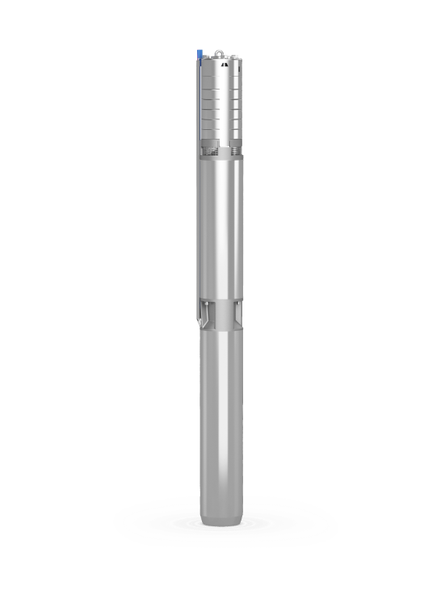

Caption:
Image: The Wilo-Actun OPTI-MS is independent of the power grid and provides optimal water output
Source: Wilo SE

Wilo Corporate Communications  Klaus Hübscher  Phone: +49 231 4102-6606  E-mail: klaus.huebscher@wilo.com | Pia Scherbach  Phone: +49 231 4102-7512  E-mail: pia.scherbach@wilo.com

About Wilo

WILO SE is one of the world’s leading premium suppliers of pumps and pump systems for building services, water management, and the industrial sector. We are increasingly developing from a component manufacturer to a system supplier and aim to set standards for high-tech in the pumping sector as an international innovation and technology leader. With smart solutions that will connect people, products and services, the Wilo Group is aiming to be the digital pioneer in the sector by 2020. The company owes its success to its workforce of over 7,700 employees in more than 60 subsidiaries around the world.

